Software Requirements Specification
for
CAC Management System
Version 1.0
Prepared by Udara Jayawardhane
Owned by Nipuni Rajapaksa
Chandrika Agri Center
20.03.2019
Table of Contents
Table of Contents ii
Revision History ii
1. Introduction 1
1.1 Purpose 1
1.2 Document Conventions 1
1.3 Intended Audience and Reading Suggestions 1
1.4 Product Scope 2
1.5 References 2
2. Overall Description 3
2.1 Product Perspective 3
2.2 Product Functions 3
2.3 User Classes and Characteristics 4
2.4 Operating Environment 4
2.5 Design and Implementation Constraints 4
2.6 User Documentation 4
3. External Interface Requirements 5
3.1 User Interfaces 5
3.2 Hardware Interfaces 10
3.3 Software Interfaces 10
3.4 Communications Interfaces 10
4. System Features 11
4.1 Login & User Level Specification 11
4.2 Dashboard 11
4.3 Stores & Packing Lists 12
4.4 Inventory 12
4.5 Maintenance 12
4.6 People 13
4.7 Employee Portal 13
5. Other Non-Functional Requirements 14
Appendix A: Glossary 15
Appendix B: Analysis Models 16
Appendix C: To Be Determined List 17

Revision History
Name | Date | Reason For Changes | Version

Introduction

Purpose
Chandrika Agri Center is currently an emerging manufacturer & provider of fertilizer in Sri Lanka, which is a stern pillar in building the economic infrastructure of any country. Currently as it stands, in 2019, the company consists of several segmented processes handled by about 25 employees and a corporate team for the administrative task performances.

With the budding of the company and upscaling being prominent at the time of concern, the management sector pertinent to performing administrative functions is in need of a control system in place to avoid complications and efficiency compromises that are potentially viable for any emerging company.

This SRS document covers the areas of concern pertinent to the target audience of the final software solution provided during the course of this project. Specifics include information relevant to system design, interfaces, functionality, usability and analysis models. Furthermore the division of sub-systems and their functions are also thoroughly discussed moving forward.

Document Conventions
The entire project documentation strictly follows the Prince2 Project Management methodology, as well as PMBOK Project Management practices where necessary. Previous documents would be referred where required, within the document itself.

Intended Audience and Reading Suggestions
The target audience for this SRS document can be categorized as mentioned.
Developers: Developers can utilize the information to focus where their efforts should be focused in developing the product and achieving required targets. The SRS would prove as a methodical guideline for programme extension, testing as well as future development.

Project Manager: Project Managers could compare project stages and have a clear vision for the future with the help of this SRS document in directing the team towards better efficient strategical project approaches and customer satisfaction.

Quality Assurance: Quality Assurance agents are able to incorporate this document in evaluating the quality of the project in moving forward. The document would provide the quality of service rendered by the project and that could be compared with initial requirements analyzed with respect to the client.
Project Executive: In assessing the project progress and evaluating performance, the Project Executive could use this SRS document as a considerable milestone. Furthermore, in evaluating if the project vision is carried safely towards the project closure, this would render itself valuable.

End Users: End Users or in this particular case the staff at Chandrika Agri Center, could use this document to understand the real life use cases and functionality of the Management System solution provided by the project team.

Product Scope
The CAC Management System software solution aims to bring technological infrastructure to a budding industrial fertilizer manufacturing company. The systematic approach to deploy the software solution would provide enough edge for the client to reinforce the efficiency of company workforce and reduce multiple overheads associated with extra labour and other costs. Thus staying ahead of competitors with the aid of the project outcome would be beneficial for solidifying the company reputation and favourable marketing as well.

Furthermore, information relevant to the business strategies, corporate goals and objectives are mentioned in previous project documents mentioned, to avoid redundancies.

CAC Management Systems/Project Brief
CAC Management Systems/Business Case

References
Previous project documentation was referred in making of this SRS document. Overall project documentation can be found on University of Bedfordshire Blackboard at www.breo.beds.ac.uk.
Since only authorized personnel are allowed to access the project module through the above referred link, the project team’s personal online drive, “SPPM” could be accessed for necessary documentation through www.drive.google.com/open?id=1_psA72eRQXw4Z7RVylcpKtEUlA2MUkA3

Some of the included documents which were utilized to realize this document are as follows;
Project Mandate, Project Brief, Communication Plan, Project Initiation Document, Business Case, Project Approach & Logs.

Overall Description

Product Perspective
As previously discussed in Chapter 1, CAC Management Systems was initiated as an idea to increase the efficiency and performance within the company of our client, Chandrika Agri Center. With no proper technological management infrastructure in place, the project was born as an original first version software system to introduce the company to its first IT based leap in company history.

Initially the project was developed in accordance to five management categories. Namely these were, process, inventory, stock, employee and machinery. However, since the stage of prototyping these components into which the system was categorized trickled down to more user friendly sub-system components within the project with respect to client requirement changes and acknowledgements. At present, the components with finalized naming and altercations of functionality inclusions are as follows.

CAC Management System

Dashboard
Stores & Packing Lists
Inventory
Maintenance
People
CAC Employee Portal

Attendance
Leave Application
As depicted, through the course of the project, as an exciting requirement to be provided, an attendance tracking system utilizing ID scanning also has been implemented, thus making itself a software interface for the main Management System.

Product Functions
Mentioned below is the bulleted functions list that can be seen within the CAC management system. These functions will be discussed clearly in section 3 under system features.
- Login/ Logout
- Manage System Users
- Change/ Forget Passwords
- Add/ Edit/ Delete/ Search/ Print details of machinery, tools, and repairs
- Add/ Edit/ Delete/ Search/ Print details of customers, employees and suppliers
- Generate ID barcodes and mail employee information
- Add/ Edit/ Delete/ Search/ Print details of fertilizer, chemicals, plants, and recipes
- Generate charts to display vehicle availability, product variants.
- Display quick access tables on supplier contact details and machinery repair status

Furthermore, the Employee Portal sub-system that was separated after being developed as an exciting requirement within the main system; due to significant behaviour, exhibits the functions mentioned below.
- Record attendance and leaves
- Apply for leave
- Obtain reports of attendance
- Add/ Edit/ Search/ Delete leave and attendance/ leave records
- Scan ID barcodes

User Classes and Characteristics
Developers: Programmers who have a sound knowledge in Java and Windows related expertise could potentially use this version of the software to extend it at any point. Since the system was built using free open source software, this process is assisted further in terms of future proofing.

Proprietor of Chandrika Agri Center: The Owner would be the highest level in the company hierarchy as well as in using the CAC Management System. This will enable him/her to obtain crucial information as well as to consult staff regarding any changes required for mitigating potential imminent risks.

IT Staff of Chandrika Agri Center: While the owner holds final say, the IT staff would be responsible for monitoring the system and utilizing its capabilities to validate requests, inform changes, follow orders and maintain a smooth flow within the company processes.

Employees of Chandrika Agri Center: While company supervisors can look into information regarding manufacturing requirements (stocks, inventory, recipes etc.), all employees in general at each level in the company hierarchy could obtain personal records to evaluate future plans, especially regarding applying leave.

Operating Environment
CAC Management System is developed to run on Windows OS and would be capable of being supported by all versions of updates since Windows 7. The system would not be configurable with Mac OS or Chrome OS. While hardware itself does not prove as a huge requirement, current generation core i3 processors or equivalent, along with standard RAM (4GB) and VGA (2GB) specifications would suffice even considering future improvements.

However, the Employee Portal attendance record sub-system would require a USB powered barcode scanner in order to scan ID barcodes of employees.

Design and Implementation Constraints
Only major development related constraint was observed throughout the project duration and that can be recorded as a system limitation/ constraint put forward by the client, requiring the project team to disregard company financial records and finance related sections when developing the software solution.

The final system would be operational only under Windows Operating Systems with versions later than Windows 7, which is based on the existing hardware infrastructure within the company.

User Documentation
Final user documentation would be provided at the closing stage of the project.
Till then all questions regarding the CAC Management System would be answered by our Project Manager, Nipuni Rajapaksa through nipunigk@gmail.com.

To obtain documentation which were provided and shared with the project board and client, refer section 1- References.

External Interface Requirements

User Interfaces
The structure of the user interfaces will be explained with sample screenshots of the system as follows. All main user interfaces designed according to the screen resolution of 1200 x 610.
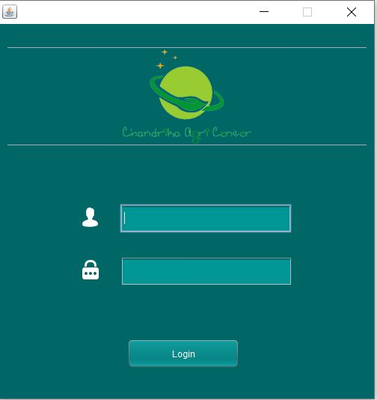

Displayed here is the initial login screen of the system. Minimize and Exit buttons are displayed along the top right corner and are available across all interfaces.

The user is greeted with the company logo and prompts to enter details for login.

Once details are entered and the login button is clicked, the user is validated and transferred to the system dashboard.

Shown below are screenshots of the dashboard contents.

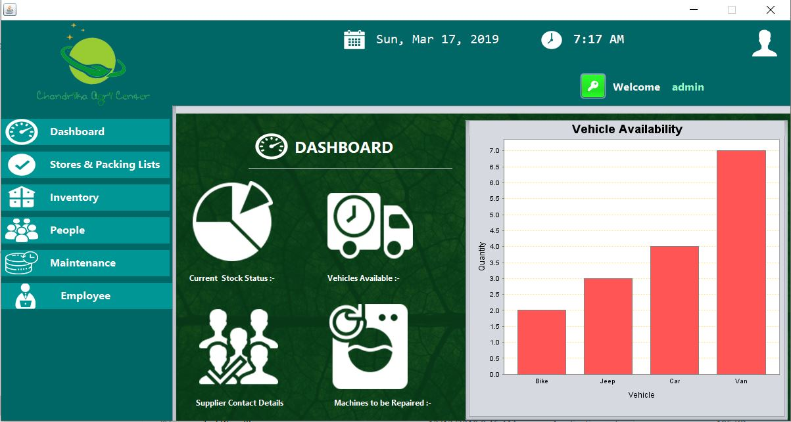

As shown, when entering into the main interface of the CAC Management System, the user is greeted along with the username while his/ her submitted profile picture is also displayed above. The key icon can be used to manipulate account activity.
The date along with time is displayed in each interface here onwards and the company logo also prevails on the left upper corner of the screen. Below that is the vertical navigation panel that contains buttons for each section in the system.
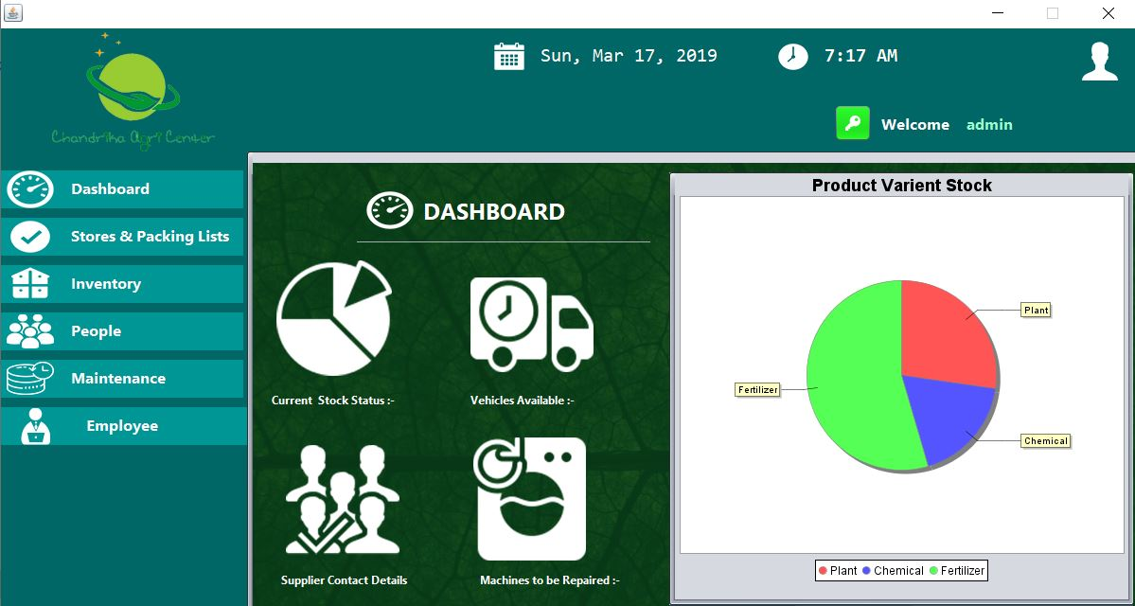
The chart/table area in the main dashboard interface allows the system to generate quick access information regarding the current company status pertaining to manufacturing and maintenance. The four panels within the dashboard and their contents will be discussed in detail, later.

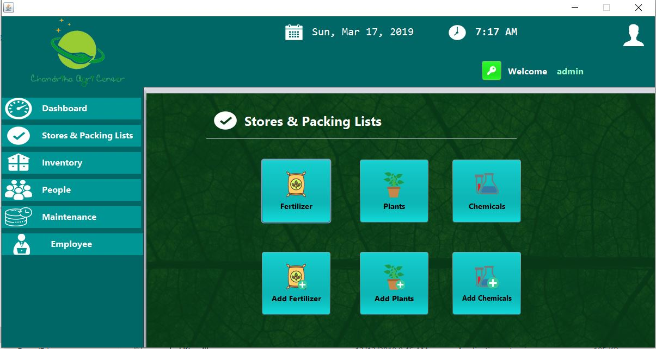
Each of the buttons in the navigation panel leads to internal interfaces regarding each sub component of the system as shown below.

Each of the buttons within these sub components lead to forms for entering details and tables containing information for reference as the following image depicts.
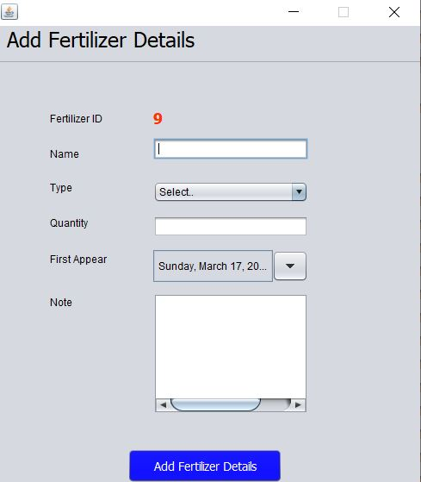
Shown here is an example for a form used to add details into the system. As observed, ID’s for all products are auto generated and forms follow a structure containing text field inputs, drop down menu inputs, date/ time inputs and text area inputs.

The blue confirmation button when clicked finally directs the verified data into the database relevant to the component.

This information can be retrieved from the database to be put into tables for reference as follows. In here users with higher powers such as the system admins are able to edit/ delete/ search details of the records or print reports. This structure is followed through on most interfaces pertaining to information retrieval.

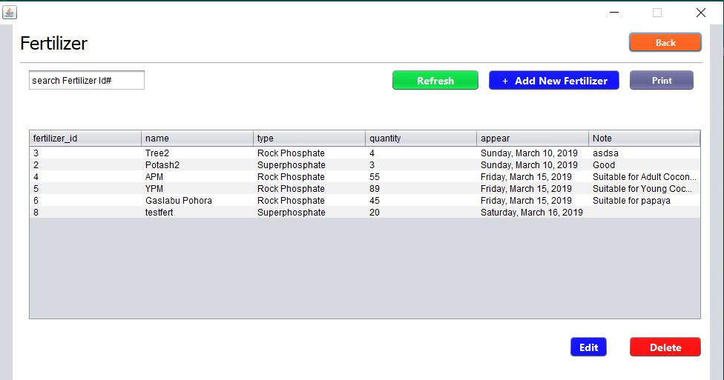

Some of these sub components contain detailed information about a certain product, such as the chemical/ fertilizer recipes displayed below.

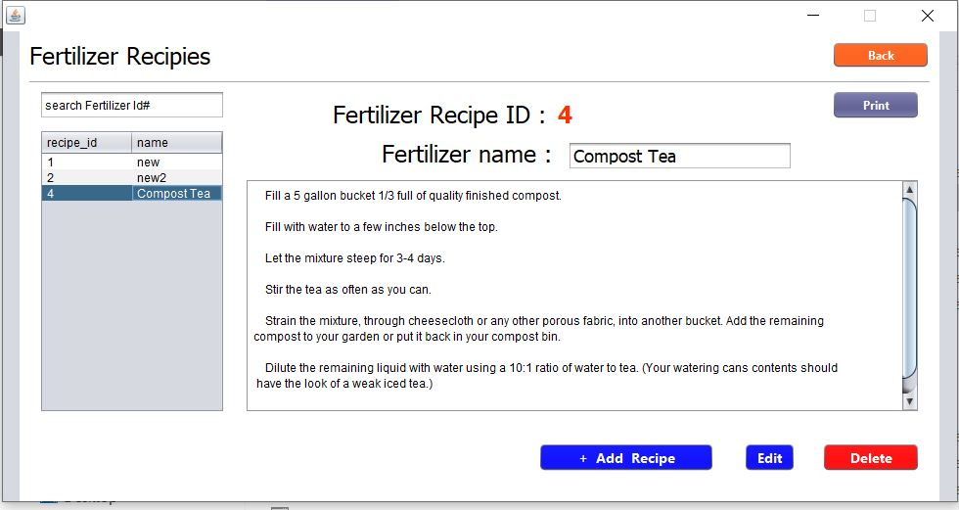

A rather different interface can be seen on the employee detail entering form. This is particularly owing to the amount of information it obtains. The employee ID numbers are automatically generated along with the barcodes particular to each of them.
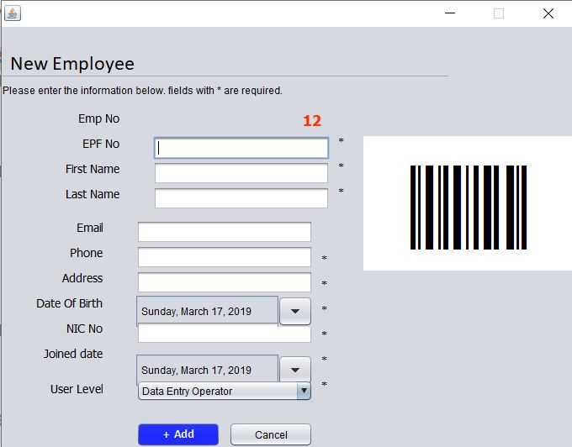

This employee form interface represents the same dynamics present within the other sections of the people sub component of the CAC Management System.

While details of employees are entered, user levels are also described for each person, enabling multi user capability with different user capabilities.

The users of the system can also change their credentials anytime. The respective interface is as below.

The highlighted title bar with the icon provides the visual representation of a utility/ settings section while the interface prompts the user to enter existing current password and double type the new password for extra confirmation.

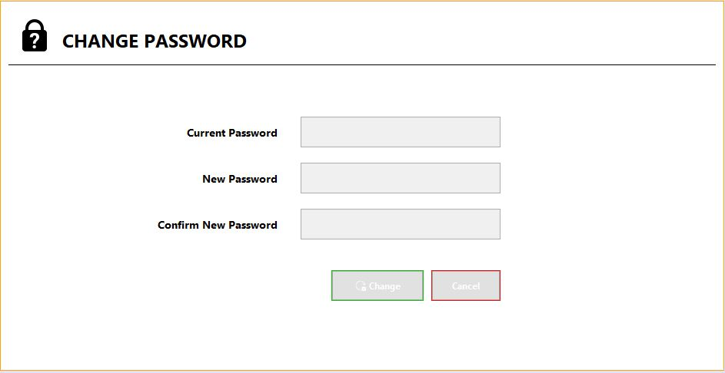
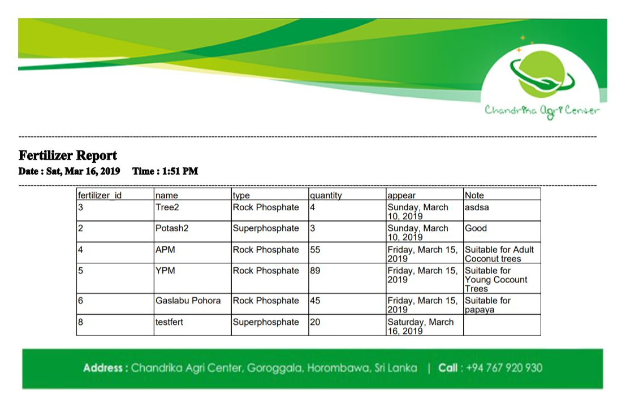
Finally all the information is retrieved as digitally automated company reports, and the appearance of that final output is as follows. Each of the reports relevant to each subcomponent of the system would produce identically designed documents with company header and footer, which contain component information as well as the date and time of access.

Hardware Interfaces
While the implemented system supports devices running Windows Operating System above Windows 7 as explained earlier, a USB powered Barcode Scanner is also required for operating the system component relevant to managing the employee attendance and leave management section.

Software Interfaces
In realizing the software artefact of the project, other third party software used include “Netbeans” which is a Java based programming IDE and MySQL for database design.

Furthermore, there exists a component of the system that separated in forming a sub-system, currently code named as the “Employee Portal”. This sub-system is responsible for taking actions regarding employee attendance and was separated to be run parallel with the main system on a different thread. While the information traversed is not necessarily co-dependent between the main system and this particular sub-system, the employee details are common and that connects the two components together.

Communications Interfaces
The employee registration procedure as previously discussed generates an ID based on a barcode. The details of this and the registration are programmed to be e-mailed to the employee via HTTP protocol. Furthermore to download and update the application, internet could be utilized optionally.

Overall; as a summary however, the system requires no communication interfaces since all the built in functionality can be carried out offline.

System Features
In section 2, product features available within the system were clearly laid out in bulleted points. Here, those capabilities will be discussed thoroughly with respect to the sub components of the system and the initial overall product breakdown. Since all the features mentioned here are already implemented, no priority levels are required to be mentioned. This section will behave as a guideline for future extension of system functionality and scope.

The CAC Management System was developed to cater the sub systematic needs pertinent to the sections of process management, inventory management, stock management, machinery management and employee management on client request. Along the course of the project, especially after prototype demonstration; the capabilities of each section were adjusted according to more suitable layouts. Hence the subcomponents of the system are categorized as follows.

- Dashboard
- Stores & Packing Lists
- Inventory
- Maintenance
- People

Noteworthy changes include stock management being converted to stores and packing lists for chemicals and fertilizer recipes with stock information being pushed into the dashboard section, machinery management being expanded into maintenance with more assets being included, and employee management being converted to a people section, followed by inclusion of supplier/ customer information. Furthermore the employee attendance related component was extracted and re-established as a high priority sub-system enabling the main management system to run parallel with the attendance management component.

However, before all the main functionalities are accessible, users have to login to the system. Therefore the system feature flow will begin from the system login and move onwards discussing and analyzing about the main sub components which comprises of a wide range of functionalities.

Login & User Level Specification
Before you enter the system and use it, each user has to login to the system. The login interface as previously displayed in section 3, prompts the user to enter their username and password. Upon verification, the user is led to the main interface area of the system.

However, the functionality within the system is not always accessible to each user. Upon thorough analysis, in order to better serve the company purposes, user levels were established according to the company hierarchy. This revokes the ability to input/ modify company details once within the system unless you are an authorized high level user in the company staff. This can be useful especially in cases such as when lower level employees need to check their attendance reports before applying for leave and manufacturing supervisors needing to check for raw material availability for recipes and production purposes in general. Also this would establish a faster approach in some regards of company activities owing to lack of information traverse required along the employee hierarchy for simple purposes.

Dashboard
Once logged in to the CAC Management System, the user is transferred directly to the dashboard interface. This component provides all the quick access information necessary for daily company management processes.

Here the user would be able to select a particular summary out of four available panels namely, current stock status, vehicle availability, supplier contact details and machines to be repaired. The user will be able to click on the required information summary and it would be displayed graphically on the dashboard itself. The stock status will be represented with regards to plants, fertilizer and chemicals available by generating a pie chart. Company vehicle availability would be displayed on a bar chart with respect to the types of vehicles owned. Supplier details and machine repairs could be accessed at a glance, through tables containing all the necessary information.

Stores & Packing Lists
This component is responsible for handling all information relevant to the manufacturing materials as well as the plant products. Once the user enters this particular section, he/she would be prompted to choose between plants, chemicals and fertilizer in terms of products and adding or viewing in terms of activity.

As displayed in section 3- user interfaces, the add functionality prompts the user to enter all details regarding the selected product variant and to confirm the submission with valid details. Once the details are submitted all the records within the database relevant to all the product variants can be viewed by clicking on each view button. The view button for each product variant leads to a tabular informative interface where the user is capable of editing, searching, deleting and printing the records that are available. This type of interface reduces clutter and an add button within this interface again leads to the form mentioned previously. The search functionality being functional on any attribute specified further enables efficient process.
However as mentioned earlier, the user level defines the capabilities mentioned. Low level employees would only be able to view the information while higher ranking employees would have access to all of the functionalities capable.

Inventory
Inventory consists of mainly two categories, fertilizer recipes and chemical recipes. Each of the sections contains buttons for adding details and viewing information for the relevant recipe type. Adding prompts user to input data regarding the recipe and specifically, the steps of producing the recipe are entered here. Once submitted, similar recipes could be found when clicking the view button. Here the search function is intended to be conducted with ID’s while options remain adamant with report printing, editing content of recipes, deleting content and adding more recipes being available within the same interface.

With accordance to the user level specifications, here also all the editable functionality is reserved for high level employees with only viewing being available for the low level users. In general, employees/ supervisors would have an ability to refer to recipes and chemical information when necessary.

Maintenance
With machinery management being extended to include tools as well, maintenance now comprises of several sections in terms of functionality. Upon entry to this component of the system, the user is prompted to select between two actions as the usual flow persists. The user is able to add details or view information regarding company maintained machinery, tools, repair schedules and service schedules.

When adding details, the user is required to enter details of the respective sub section. Upon submission the details relevant to each section of machines, tools, repairs and services are available via the view button functionality. This leads to individual tabular summaries of the information required and each of the tabular view interfaces provides options of edit content, delete content, search content and print reports. If the user insists on adding more inputs, the add button in each sub section will transfer him/ her to the respective forms for detail input.

Higher level employees would be capable of manipulating the details as required or ordered but throughout the system; lower level employees would only be capable of viewing specified information. However, this satisfies the employees since it enables employees to use machines/ tools properly and to inform supervisors in advance about outstanding repairs and oncoming service dates which would in return increase machine durability and reduce overhead costs in the long run.

People
Initially, this section was planned to be limited for the purpose of recording data regarding employees within the company. However, after the prototype demonstration, necessary steps were taken to increase the possible capabilities within this particular section and in providing more useful information through the system.

Once the user enters the People subcomponent, the interface prompts him/ her to select between two personnel categories and two action choices which is the running unified theme within the composed system. The user is able to add details of suppliers and employees with a usual form structure but the employee registration contains some noteworthy features which were added as exciting functional requirements. Once the user chooses to enter a new employee registration, it prompts a form for entering relevant details but more importantly, a new ID specific barcode is automatically generated once you submit the registration and this information is sent to the relevant employee through e-mail. Similarly important to note is how this form lets the admins choose the employee designation which is later used in authorizing the system accessibility.

When viewing, in both sections, records can be manipulated in terms of editing, deleting, being searched by specified attributes and generating reports through the print button. Employees are able to view their personal records for any possible requirement such as obtaining the barcode for reprinting a lost ID card, or to obtain a certain supplier’s information. Higher level users are able to view as well as edit details pertinent to day to day situations such as promoting employees within the company.

Employee Portal
Designed as a high priority sub system of the initial CAC Management System, the Employee Portal would be responsible for managing information relevant to employee attendance and leave management. This was extracted from the main system in order for it to be run in parallel.

The component provides two main functionalities which are currently run through traditional documentation processes and they are marking attendance and the leave verification process. The component would utilize a USB powered barcode scanner in order to scan the barcode generated for each employee as mentioned in the previous section. This would automatically mark the employee’s attendance thus, reducing unnecessary paperwork and difficulties in maintaining attendance logs/ registers. When necessary attendance reports could be generated through a print function and would provide details about the employees’ attendance with respect to attributes like current state, number of leaves obtained/ remaining. This is useful in enabling employees to view their available leaves and attendance regularly, which would reduce the employer-employee conflicts. Furthermore, employee encouragement can be uplifted with assessing the attendance and awarding them using the system reports as reference.

When considering the process of applying leave, the employees can apply leave at any time by filling out the form prompted by the system. This will be sent to a table of requests where the person in charge of leave approval can confirm, deny or let the request stay in pending as required. This would enable quicker information traverse to and back from the higher level officers and employees would be pleased/ motivated in having the ability to stay in touch with the state of their requests and performances regularly.

Other Non-Functional Requirements
- Simplicity:
The system should be simple enough to be understood by the wide range of possible users and all functionality capabilities should be available without any complicated, unnecessary redundancies.

- Reliability:
The software should be capable of performing promised tasks to a great extent without any malfunctions or system errors.

- Availability:
The system should persistently be up and running when required during the established operating times.

- Reusability:
The system should have a considerable ability in being used for implementing new software systems with modularity being a prominent aid in the cause.

- Scalability:
The system should be capable of growing with the growth of the company which would be the main benefit of the system implementation. It should be capable of expanding its capabilities with respect to the probably imminent company upscaling.

- Installability:
The system should be easily installed, uninstalled and reinstalled into any specified target environment.

Appendix A: Glossary
SRS: System Requirement Specification
CAC: Chandrika Agri Center
IDE: Integrated Development Environment
HTTP: Hyper Text Transfer Protocol
Netbeans: A Java based programming IDE
MySQL: An open source relational database management system

Appendix B: Analysis Models
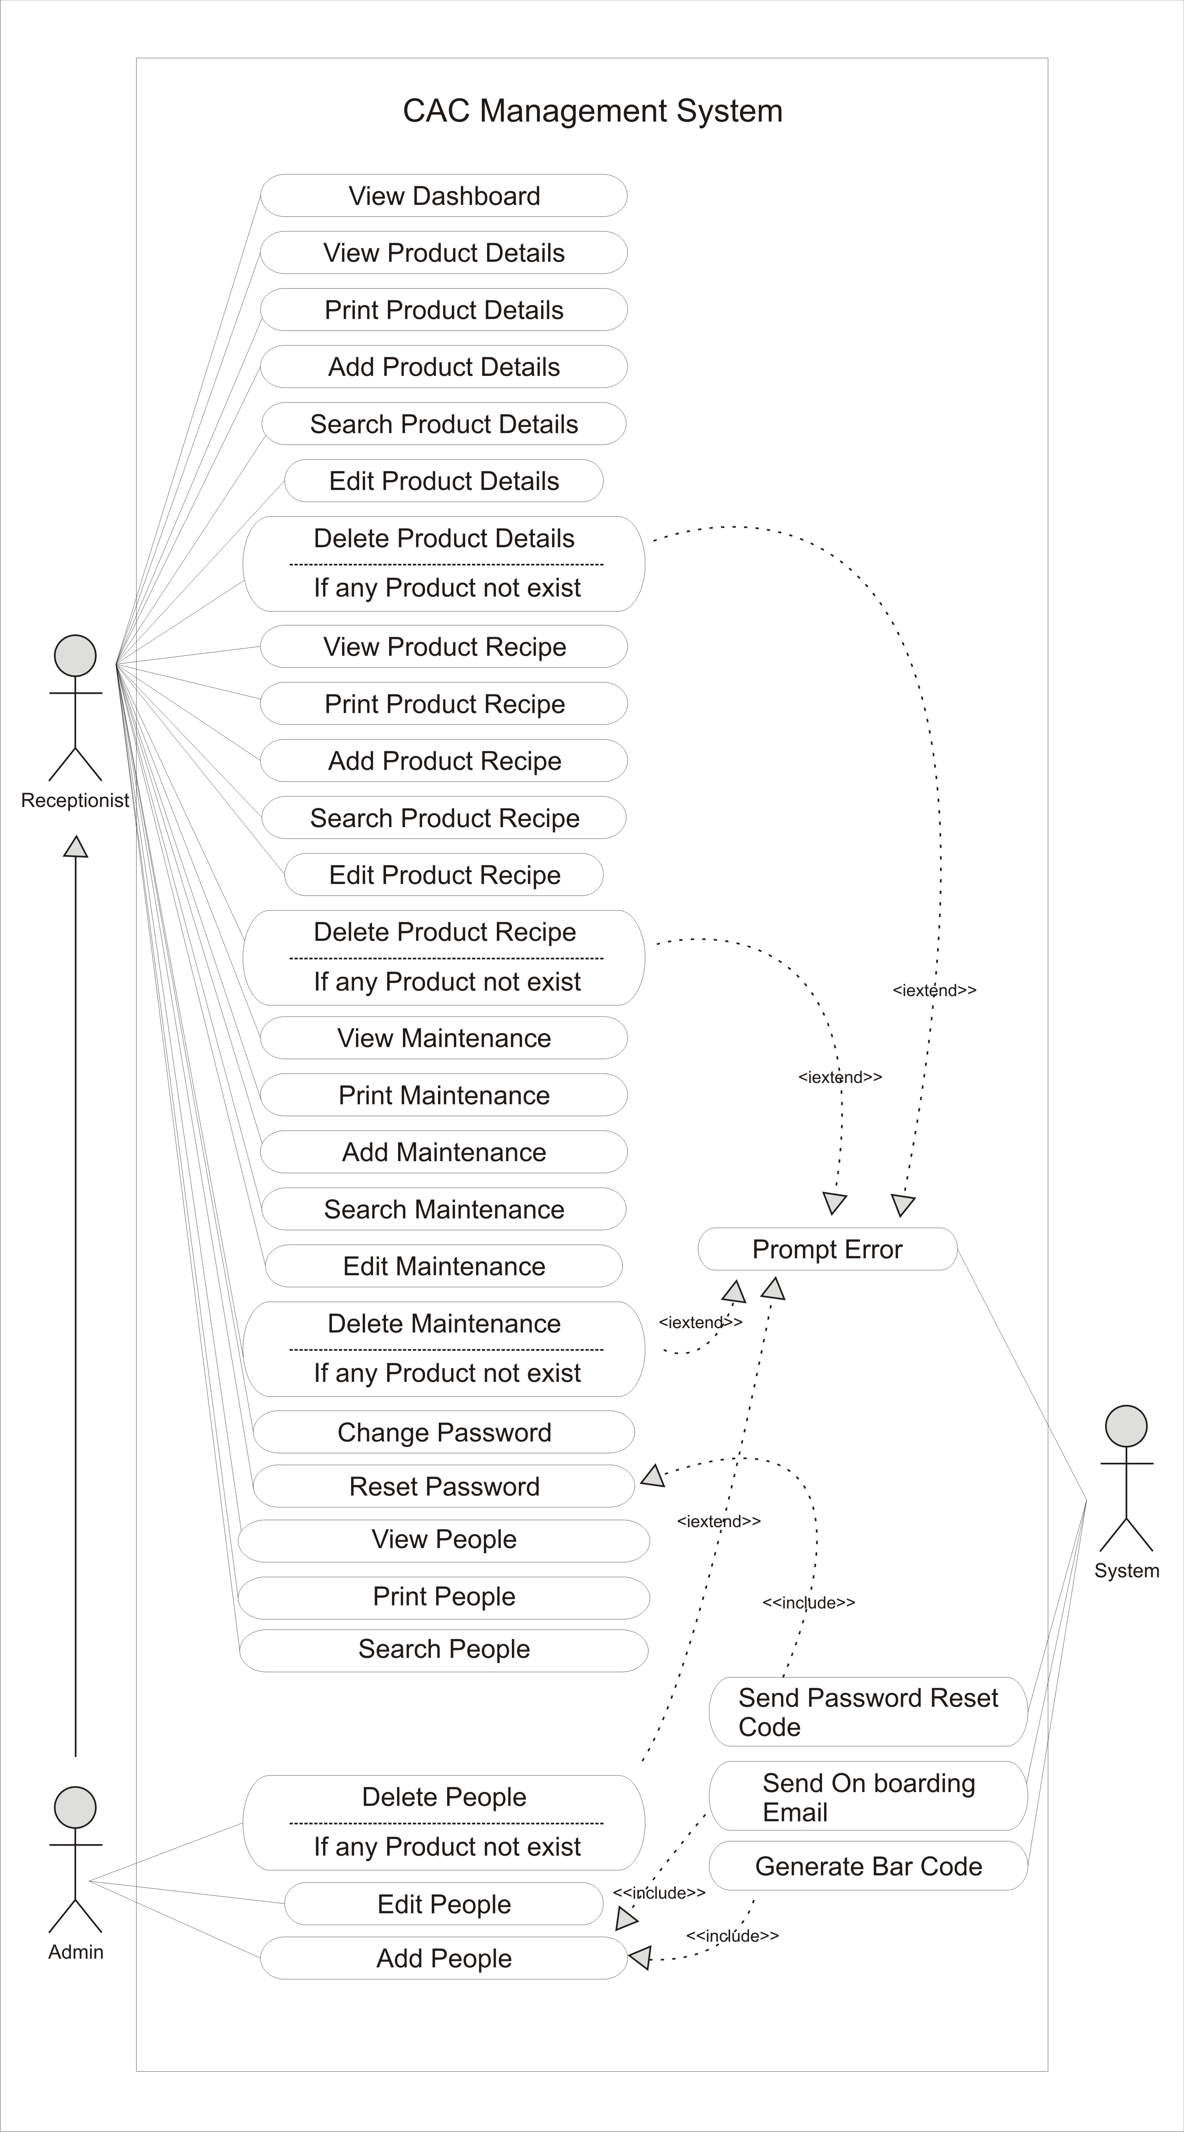
- CAC Management System Use Case Diagram
- CAC Management System Entity-Relationship Diagram
